Install by cloning from another Tails on PC

You need

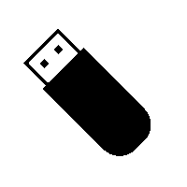

1 USB stick

8 GB minimum

All data will be lost!



a smartphone

another computer,  
or a printer  
to follow the instructions



another Tails

USB stick or DVD



½ hour

Your steps

[[](https://tails.boum.org/install/clone/pc/index.de.html#other)](https://tails.boum.org/install/clone/pc/index.de.html" \l "other)

[Restart on the other Tails](https://tails.boum.org/install/clone/pc/index.de.html" \l "other)

[[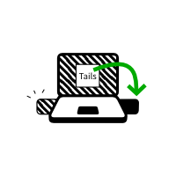](https://tails.boum.org/install/clone/pc/index.de.html#install)](https://tails.boum.org/install/clone/pc/index.de.html" \l "install)

[Install Tails by cloning](https://tails.boum.org/install/clone/pc/index.de.html" \l "install)

[[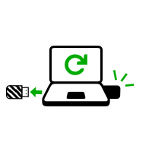](https://tails.boum.org/install/clone/pc/index.de.html#restart-new)](https://tails.boum.org/install/clone/pc/index.de.html" \l "restart-new)

[Restart on your new Tails](https://tails.boum.org/install/clone/pc/index.de.html" \l "restart-new)

[[](https://tails.boum.org/install/clone/pc/index.de.html#new)](https://tails.boum.org/install/clone/pc/index.de.html" \l "new)

[Welcome to your new Tails!](https://tails.boum.org/install/clone/pc/index.de.html" \l "new)

If you already started on the other Tails, go directly to step 3: [Verify that the other Tails is up-to-date](https://tails.boum.org/install/clone/pc/index.de.html" \l "verify-other).

Open these instructions on another device



In the next step, you will shut down the computer. To be able to follow the rest of the instructions afterwards, you can either:

* Scan this QR code on your smartphone or tablet:



* Print these instructions on paper.
* Take note of the URL of this page:

https://tails.boum.org/install/clone/pc?back=1

Restart on the other Tails



Make the computer start on the USB stick

Most computers do not start on the Tails USB stick automatically but you can press a Boot Menu key to display a list of possible devices to start from.

If Windows 8 or 10 is installed on the computer, you can refer instead to the [instructions on starting Tails from Windows 8 or 10](https://tails.boum.org/doc/first_steps/start/pc/index.de.html" \l "windows-restart). Starting Tails from Windows is easier than using the Boot Menu key.

The following screenshot is an example of a Boot Menu:

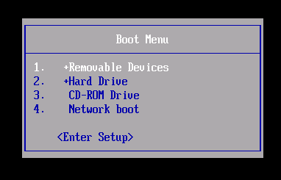

This animation summarizes how to use the Boot Menu key to start on the USB stick:

The following instructions explain in detail how to use the Boot Menu key to start on the USB stick:

1. Fahren Sie den Computer herunter.

Plug in the other Tails USB stick that you want to install from.

1. Identify the possible Boot Menu keys for the computer depending on the computer manufacturer in the following list:

|  |  |
| --- | --- |
| **Manufacturer** | **Key** |
| Acer | F12, F9, F2, Esc |
| Apple | Option |
| Asus | Esc |
| Clevo | F7 |
| Dell | F12 |
| Fujitsu | F12, Esc |
| HP | F9 |
| Huawei | F12 |
| Intel | F10 |
| Lenovo | F12 |
| MSI | F11 |
| Samsung | Esc, F12, F2 |
| Sony | F11, Esc, F10 |
| Toshiba | F12 |
| others… | F12, Esc |

1. On many computers, a message is displayed very briefly when switching on that also explains how to get to the Boot Menu or edit the BIOS settings.
2. Schalten Sie den Computer ein.

Immediately press several times the first possible Boot Menu key identified in step 2.

1. If the computer starts on another operating system or returns an error message, shut down the computer again and repeat step 3 for all the possible Boot Menu keys identified in step 2.

If a Boot Menu with a list of devices appears, select your USB stick and press **Enter**.

1. If the computer starts on Tails, the Boot Loader appears and Tails starts automatically after 4 seconds.

Black screen ('GNU
GRUB') with Tails logo and 2 options: 'Tails' and 'Tails (Troubleshooting
Mode)'.

Troubleshooting

* If none of the possible Boot Menu keys from the previous technique work, or if your USB stick is not listed in the Boot Menu, refer to the [troubleshooting instructions about Tails not starting at all](https://tails.boum.org/doc/first_steps/start/pc/index.de.html" \l "not-at-all).
* If your USB stick is listed in the Boot Menu but the Boot Loader does not appear:
  1. Try installing again on the same USB stick.
  2. Try installing on a different USB stick.
  3. Try using the same USB stick to start on a different computer.

If your computer still does not display the Boot Loader, it might currently be impossible to start Tails on your computer.

* If the Boot Loader appears but Tails fails to start after the Boot Loader, refer to [the troubleshooting section about Tails not starting after the Boot Loader](https://tails.boum.org/doc/first_steps/start/pc/index.de.html" \l "not-entirely).



Starting Tails

1. After the Boot Menu, a loading screen appears.



1. One to two minutes after the Boot Loader and the loading screen, the Welcome Screen appears.

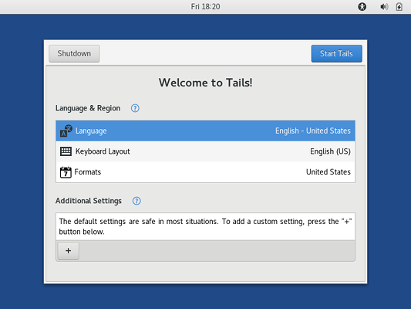

1. In the Welcome Screen, select your language and keyboard layout in the **Language & Region** section. Click **Start Tails**.
2. Nach 15–30 Sekunden erscheint der Desktop von Tails.

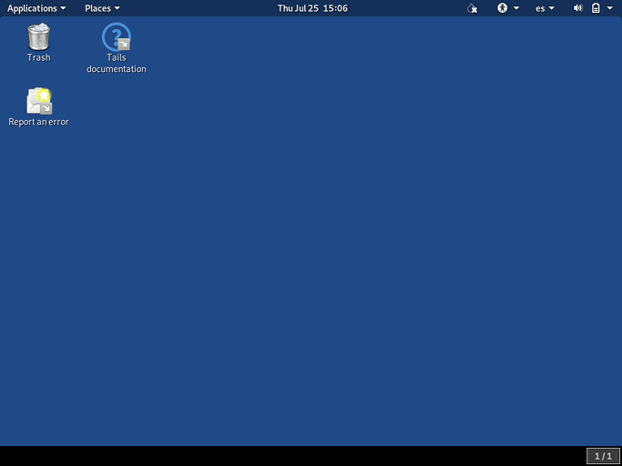

Verify that the other Tails is up-to-date

To prevent installing an outdated version of Tails with known security issues, make sure that the Tails you are installing from is up-to-date:

1. Choose **Applications ▸ Tails ▸ About Tails**.
2. Stellen Sie sicher, dass die Version, die Sie benutzen **Tails 5.1.1**ist und am 2022-06-23 veröffentlicht wurde:

a. Wenn Sie 5.1.1 verwenden, können Sie mit dem nächsten Schritt fortfahren.

b. Wenn Sie nicht 5.1.1 benutzen, verbinden Sie sich mit dem Internet und warten Sie, bis Tor fertig ist. Nach ein oder zwei Minuten erscheint der *Tails Upgrader* mit Anweisungen, wie eine Aktualisierung durchgeführt wird. Führen Sie alle Aktualisierungen durch, nach denen Sie gefragt werden.

Install Tails by cloning



1. Plug the new USB stick in the computer.

All the data on this USB stick will be lost.

1. Choose **Applications ▸ Tails ▸ Tails Installer**to start *Tails Installer*.

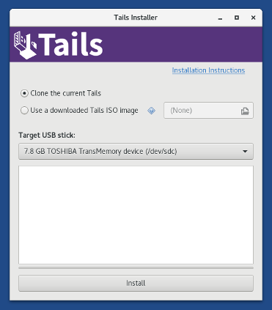

1. Choose the new USB stick in the **Target USB stick** drop-down list.
2. To start the installation, click on the **Install** button.
3. Lesen Sie die Warnmeldung im Bestätigungsfenster. Klicken Sie auf **Yes**, um sie zu bestätigen.

The installation takes a few minutes.

The progress bar usually freezes for some time while synchronizing data on disk.

1. After the installation finishes, close *Tails Installer*.

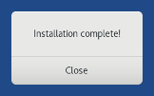

Restart on your new Tails



1. Fahren Sie den Computer herunter.
2. Unplug the other USB stick and leave the new USB stick plugged in.
3. Switch on the computer and start on your new Tails USB stick.
4. The Boot Loader appears and Tails starts automatically after 4 seconds.
5. After 30–60 seconds, the Welcome Screen appears.
6. In the Welcome Screen, select your language and keyboard layout in the **Language & Region** section. Click **Start Tails**.
7. Nach 15–30 Sekunden erscheint der Desktop von Tails.

Welcome to your new Tails!



Test your Wi-Fi

Problems with Wi-Fi are unfortunately quite common in Tails and Linux in general. To test if your Wi-Fi interface works in Tails:

1. Open the system menu in the top-right corner:

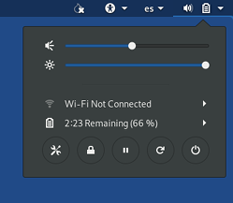

1. Choose **Wi-Fi Not Connected** and then **Select Network**.
2. After establishing a connection to a local network, the *Tor Connection* assistant appears to help you connect to the Tor network.

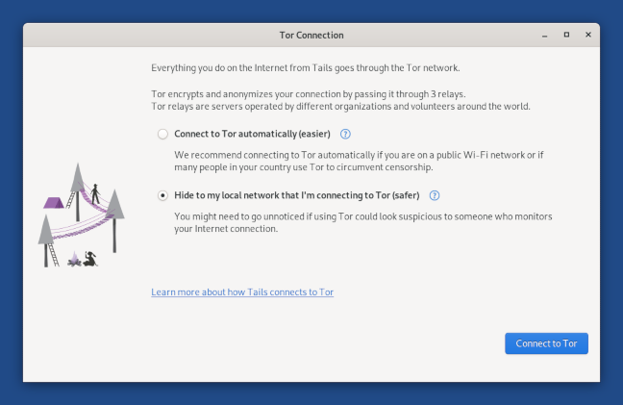

If your Wi-Fi interface is not working, for example:

* There is no Wi-Fi option in the system menu:

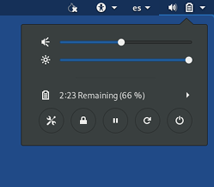

* You receive the notification **Connection failed: Activation of network connection failed**.
* The interface is disabled when starting Tails or when plugging in your USB Wi-Fi adapter:

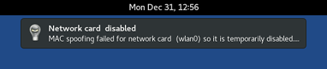

In this case, you can disable MAC address anonymization to get your Wi-Fi interface to work in Tails. Disabling MAC address anonymization has security implications, so read carefully our [documentation about MAC address anonymization](https://tails.boum.org/doc/first_steps/welcome_screen/mac_spoofing/index.en.html) before doing so.

To connect to the Internet, you can try to:

* Use an Ethernet cable instead of Wi-Fi if possible. Wired interfaces work much more reliably than Wi-Fi in Tails.
* Share the Wi-Fi or mobile data connection of your phone using a USB cable. Sharing a connection this way is called *USB tethering*.



See instructions for:

* + [iPhones or iPads](https://support.apple.com/en-us/HT204023)

Only sharing mobile data works on iPhones and iPads; sharing Wi-Fi does not work.

* + [Android](https://support.google.com/android/answer/9059108?hl=en)

Tails cannot hide the information that identifies your phone on the local network. If you connect your phone to:

* + A Wi-Fi network, then the network will know the MAC address of your phone. This has security implications that are discussed in our [documentation on MAC address anonymization](https://tails.boum.org/doc/first_steps/welcome_screen/mac_spoofing/index.en.html). Some phones have a feature to hide the real MAC address of the phone.
  + A mobile data network, then the network will be able to know the identifier of your SIM card (IMSI) and also the serial number of your phone (IMEI).
* Buy a USB Wi-Fi adapter that works in Tails:

|  |  |  |  |  |  |  |
| --- | --- | --- | --- | --- | --- | --- |
| **Vendor** | **Model** | **Size** | **Speed** | **Price** | **Buy offline** | **Buy online** |
| Panda Wireless | Ultra | Nano | 150 Mbit/s | $12 | No | [Amazon](https://www.amazon.com/d/B00762YNMG) |
| Panda Wireless | PAU05 | Small | 300 Mbit/s | $14 | No | [Amazon](https://www.amazon.com/d/B00EQT0YK2) |
| ThinkPenguin | TPE-N150USB | Nano | 150 Mbit/s | $54 | No | [ThinkPenguin](https://www.thinkpenguin.com/gnu-linux/penguin-wireless-n-usb-adapter-gnu-linux-tpe-n150usb) |

* If you find another USB Wi-Fi adapter that works in Tails, please let us know. You can write to [sajolida@pimienta.org](mailto:sajolida@pimienta.org) (private email).

Yay, you managed to start your new Tails on your computer!

If you want to save some of your documents and configuration in an encrypted storage on your new Tails USB stick, follow our instructions until the end. Otherwise, have a look at our [final recommendations](https://tails.boum.org/install/clone/index.de.html#recommendations).

Create a Persistent Storage (optional)

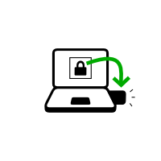

You can optionally create an encrypted Persistent Storage in the remaining free space on your new Tails USB stick to store any of the following:

* Persönliche Dateien
* Einstellungen
* zusätzliche Programme
* Encryption keys

The data in the Persistent Storage:

* Bleiben über mehrere Arbeitssitzungen hinweg verfügbar.
* Werden mit einem Passwort Ihrer Wahl verschlüsselt.

The Persistent Storage is not hidden. An attacker in possession of your USB stick can know that there is a Persistent Storage on it. Take into consideration that you can be forced or tricked to give out its passphrase.

It is possible to unlock the Persistent Storage from other operating systems. But, doing so might compromise the security provided by Tails.

For example, image thumbnails might be created and saved by the other operating system. Or, the contents of files might be indexed by the other operating system.

Other operating systems should probably not be trusted to handle sensitive information or leave no trace.

Create the Persistent Storage

1. Choose **Applications ▸ Tails ▸ Configure persistent volume**.
2. Geben Sie sowohl in dem Textfeld **Passphrase** als auch **Passphrase erneut eingeben** eine Passphrase Ihrer Wahl an.

We recommend choosing a long passphrase made of five to seven random words. [See this article about memorizable and secure passphrases.](https://theintercept.com/2015/03/26/passphrases-can-memorize-attackers-cant-guess/)

1. Klicken Sie auf die Schaltfläche **Erstellen**.
2. Warten Sie, bis das Erstellen abgeschlossen ist.
3. The list of features of the Persistent Storage appears. Each feature corresponds to a set of files or settings that can be saved in the Persistent Storage.

We recommend you to only turn on the Personal Data feature for the time being. You can turn on more features later on according to your needs.

1. Klicken Sie auf **Speichern**.

Restart and unlock the Persistent Storage

1. Shut down the computer and restart on your new Tails USB stick.
2. In the Welcome Screen:

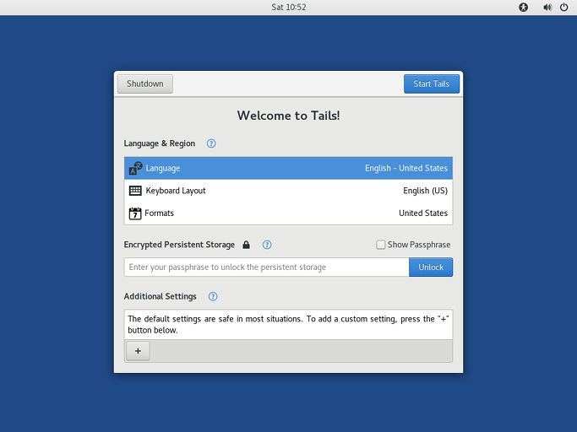

* + Select your language and keyboard layout in the **Language & Region** section.
  + In the **Encrypted Persistent Storage** section, enter your passphrase and click **Unlock** to unlock the Persistent Storage for the current working session.
  + Click **Start Tails**.

1. Nach 15–30 Sekunden erscheint der Desktop von Tails.
2. You can now save your personal files and working documents in the **Persistent** folder. To open the **Persistent** folder choose **Places ▸ Persistent**.